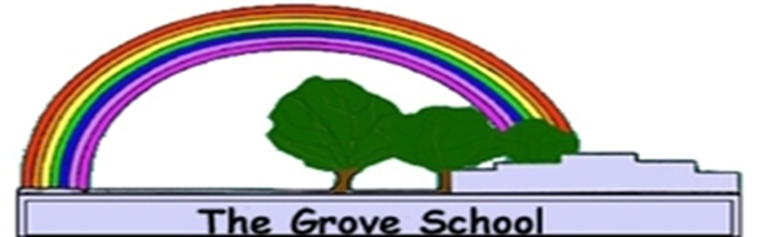

**Policy for:**

**PMLD**

**Date Written: November 2021**

**Date Reviewed: February 2024**

**Next Review Date:** **February 2026**

**Signed By: Mrs Williams**

**Governor Responsible for:**

**Headteacher: Mrs Penny Derries**

POLICY AND PRACTICE FOR WORKING WITH STUDENTS WITH PROFOUND AND COMPLEX LEARNING DIFFICULTIES.

The official DfE definition of children with PMLD is:

Pupils with profound and multiple learning difficulties have complex learning needs. In addition to very severe learning difficulties, pupils have other significant difficulties, such as physical disabilities, sensory impairment or a severe medical condition. Pupils require a high level of adult support, both for their learning needs and also for their personal care. They are likely to need sensory stimulation and a curriculum broken down into very small steps. Some pupils communicate by gesture, eye pointing or symbols, others by very simple language. Their attainments are likely to remain in the early P scale range (P1/P4) throughout their school life.

INCLUSIVE SCHOOLS

Children with profound (and complex) learning difficulties are educated at The Grove School alongside their more able peers. Sometimes they work in mixed ability groups(wheelchair dancing, P.E.) and sometimes they work on activities that are different and special to them.

All students are encouraged to participate in lessons at a level that is appropriate to them. If it enables them to participate meaningfully, they may be engaged in simplified or alternative activities alongside their peers or working separately in a different room.

We expect all our students regardless of need to be treated with dignity & respect, fairness & kindness, care & compassion.

In our work with students we would like to ensure:

• A sense of fun with clear boundaries

• Students are listened to and made to feel safe.

• Staff are vigilant to student’s needs. Through careful observation they can keep the ‘voice of the child’ at the centre of everything they do.

Personalised Learning

The curriculum is personalised for each student based on assessment of individual needs. A range of assessments are used both by classroom staff (MAPP) and representatives of the multidisciplinary teams in schools. ( physiotherapy , occupational therapy , speech therapy .)

Individual education plans are identified in consultation with classroom staff and the multidisciplinary team. These targets are likely to focus on learning fundamental skills and gaining basic understanding of the world developing learning through Learning Intentions including Communication, Cognition (Thinking Skills), Physical(Physical/sensory)and Self Help(PHSE).

As students cannot directly express their views on personal targets, observations of students from the whole class team are made regularly in the log books to ensure targets are based on current strengths and needs. These targets are reviewed regularly to ensure they are updated once met.

THE CURRICULUM

The curriculum for students with profound learning difficulties is driven by the identification of individual personal targets. However, elements of the national curriculum, the wider curriculum and relevant therapies provide a rich context within which to develop these fundamental skills and understanding. Some students may be at a very early stage of development and it may be appropriate for them to draw on a very focused curriculum: focused on developing object and social interaction skills. Others, who have mastered the basic skills of social interaction and engaging with the world, are able to benefit from a full and varied curriculum.

ASSESSMENT:

We acknowledge that our students do not follow a linear pattern of development but can still make progress. MAPP (Measuring Against Personal Progress) is the assessment used within the PMLD classes and also where appropriate in other classes throughout the school. Progress and acquisition of skills are measured using four identified criterion ‘prompting, Fluency, Maintenance and generalisation’.

MULTI-DISCIPLINARY APPROACH:

Most students with profound learning difficulties also have other difficulties, for example medical, physical and sensory difficulties. It is not possible to meet the diverse needs of this group without the help and support of other agencies such as the school nurse, occupational therapist, speech and language therapist, physiotherapist, educational psychologist, CYPs and social work involvement were appropriate.

We aim to work in a multidisciplinary fashion where all services involved with the individual student share their expertise. We meet to discuss how the student’s needs can best be met. Therapists may work alongside each other or individually but they keep each other informed through agreed lines of communication.

We are committed to working closely with families to ensure the best outcomes for students with the most complex needs. Parents or carers are involved in planning and meeting needs and help to identify priority targets.

School keeps in close contact and try to meet whole family needs wherever possible.

WORKING PRACTICE IN SCHOOL

We aim for staff to be empathic to the students’ needs at all times. General principles

* We interpret all behaviours as communicative and respond appropriately.
* We drop down to student’s eye level when we are speaking to them
* We give time for students to respond
* We show respect and give quality time to the students
* We speak to students before we move them
* Where appropriate we use objects of reference to support them with their transitions and communicating choices.
* We allow time to greet student who will need longer to respond
* We recognise that personal care is an essential part of the day and demands quality time and space to be carried out with dignity
* We are aware of the impact of the environment and ensure the best position possible for learning engagement
* We ensure that the students work with familiar people that know them well to understand their behaviour and meet their needs.
* We make time for students to choose their own food where possible
* We sit so we are at eye level with student and able to see their face (opposite or next to)
* We talk to student about what they are eating
* We blend or cut up food separately so all tastes are kept separate
* We give time to developing independence skills and ensure students hold their own spoon where they are able
* We ensure hygiene routines are scrupulous for students who have gastrostomy feeds ensuring aprons and gloves are worn and hands washed and gloves and aprons are changed each time when moving between students
* Our focus of attention is the student we are supporting and we don’t chat to other staff at this time

Amanda Williams – Classroom Manger